Analyzing Smartphone Specifications for Price Range Prediction and Market Segmentation

Ciara Frances Pataueg Comendador
17-23-4348

Mhikaela Ignacio Galo
17-23-4416

Amanda Grace Reyes Mangubat
17-23-4472

Problem Description
In the cellphone industry, many users consider the hardware and design specifications - RAM, storage space, battery size, display size, pixel density, processor and operating system, and unique features like fingerprint sensors and foldable screens--to determine if a phone is worth the cost. However, it is not always clear how these specifications, when combined, lead to a phone's actual unit price, and its price segmentation (low, mid, or high-end). Therefore, it becomes challenging for users to assess if a device is worth the asking price. This factor is compounded when smartphones that have the same hardware and design specifications are offered at markedly different prices.
This study is for smartphone users and for those wanting to use data to make more informed decisions when purchasing a smartphone.
The study will use the smartphone dataset, and will involve the use of 3 modeling techniques:
- Decision Tree
  - To determine how we can predict the price level
- k-Means
  - To understand how phones naturally group themselves based on their specs
- Association Rule
  - To identify what specs combination usually go together in each price level

Dataset Description

Column Name | Type | Missing Values | Description
phone_brand | Nominal | 0 | Brand of the smartphone
phone_model | Nominal | 0 | Model name of the smartphone
store | Nominal | 0 | Online store or source of the price
price_usd | Real | 0 | Phone price in US dollars
storage | Iteger | 0 | internal storage capacity (GB)
ram | Iteger | 0 | RAM size (GB)
launch_date | Date-Time | 0 | Launch date of the phone model
dimensions | Nominal | 0 | Physical dimensions (height × width × thickness)
weight | Real | 0 | Device weight in grams
display_type | Nominal | 0 | Screen technology / type
display_size | Real | 0 | Screen size in inches
display_resolution | Nominal | 0 | Resolution in pixels
os | Nominal | 0 | Full name of operating system
nfc | Iteger | 0 | NFC support indicator (1 = has NFC, 0 = no NFC)
usb | Nominal | 0 | USB connector type
battery | Iteger | 0 | Battery capacity (mAh)
features_sensors | Nominal | 0 | List of available sensors/features
colors | Nominal | 0 | Listed color options
video | Nominal | 0 | Video recording capabilities
chipset | Nominal | 0 | Full name of chipset
cpu | Nominal | 0 | Description of CPU
gpu | Nominal | 0 | Description of GPU
year | Date-Time | 0 | Launch year (standardized)
foldable | Iteger | 0 | Foldable design indicator (1 = foldable, 0 = non-foldable)
ppi_density | Iteger | 0 | Pixel density (pixels per inch)
quantile_10 | Real | 0 | Lower reference price (10th percentile) for similar phones
quantile_50 | Real | 0 | Median reference price (50th percentile) for similar phones
quantile_90 | Real | 0 | Upper reference price (90th percentile) for similar phones
price_range | Nominal | 0 | Price segment label (low, medium, high)
os_type | Nominal | 0 | OS family grouped
os_version | Nominal | 0 | OS version number
battery_size | Nominal | 0 | Battery description / label (variant of battery info)
colors_available | Iteger | 0 | Count of available colors
chip_company | Nominal | 0 | Chip manufacturer
cpu_core | Nominal | 18 | CPU core configuration/category
gpu_company | Nominal | 71 | GPU manufacturer
fingerprint | Nominal | 0 | Fingerprint implementation type
video_resolution | Nominal | 0 | Max video recording resolution

The dataset has:
- 1,708 examples
- 0 special attributes
- 38 regular attributes
- It has 18 missing values in cpu_core and 71 in gpu_company
- No duplicated rows

Data Exploration
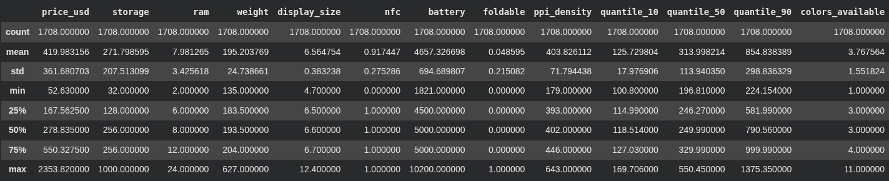

Key Findings:
- The target (class) attribute for classification is price_range (low, medium, high).
- Regular attributes include technical specs (ram, storage, battery, display_size, ppi_density, weight), price attributes (price_usd, quantile_10/50/90, price_vs_median_ratio), and categorical features (os_type, chip_company, foldable, fingerprint, nfc, usb, etc.)
- Most phones price between $170 and $550
- Average price of phones is equal to $420, while the median is equal to $279, minimum $53 and the maximum is $2354
- There is a combination of cheaper phones, lesser midrange, and a handful of very expensive flagship phones
- The median and the 75th of the given dataset is equal to 256 GB in storage, thus 256 GB is the most common storage size.
- There are a few outliers in both the low and high storage value.
- The median and the 75th of the given dataset is equal to 5000 mAh, therefore the mid range value of the battery is equal to 5000 mAh.
- The median value of the display size of phones is 6.6 inches so a majority of phones with equal to or lesser value are the modern phones with large screens.
- The median pixel density has a value equal to or somewhat equal to 402 ppi which is a good pixel value
- The range of the pixel density is between 179 to 643 ppi so the sharpness of the screen is high for some models and low for some.
- The median of weight is 193.5 g which is the most common smartphone weight.
- It ranges from 135 - 627 g indicating some models are very heavy which is likely due to either them being large in screen size or foldable.
- The mean of nfc is 0.92 indicates that 92.0% of phones have nfc.
- This indicates that nfc is a standard across the dataset.
- The mean of foldable is 0.05 which indicates that only 5.0% of the phones are foldable.
- This indicates that foldables are still a small minority.
- The median of colors available 4 is the average number of colors per phone per model.
- It ranges from 1 - 11 indicating that some of the phone models are available in a very wide range of colors while for some models, the color options are very limited.

Data Visualization
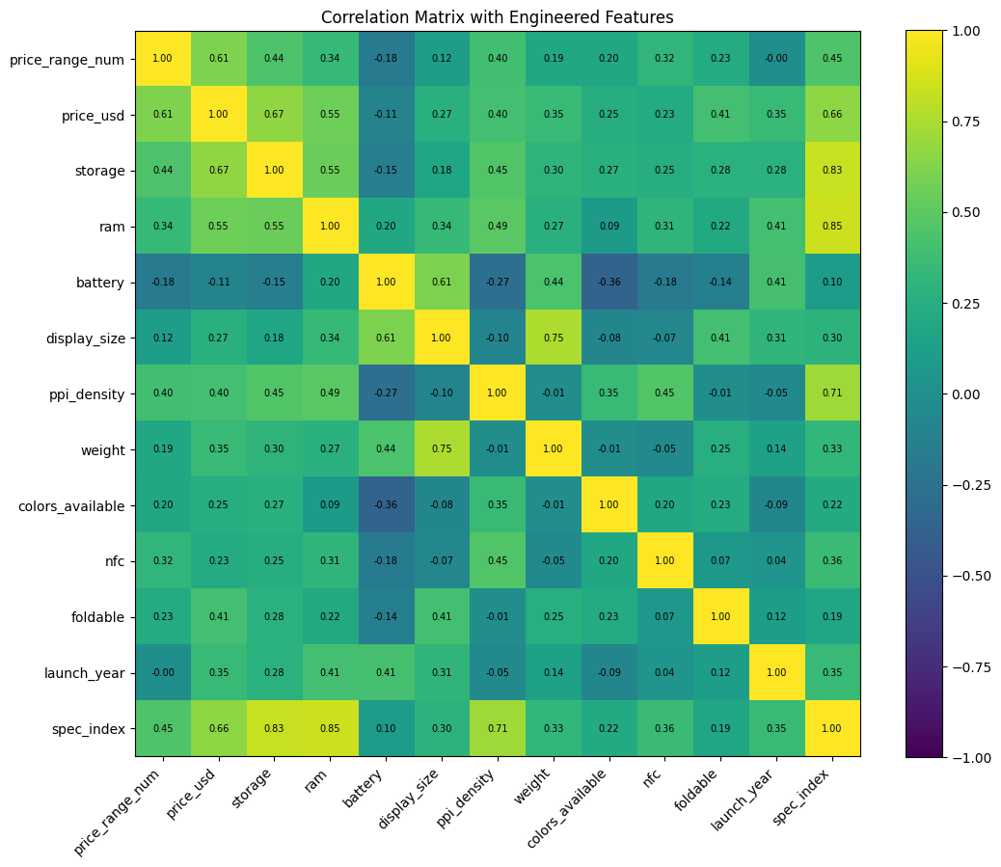

Correlation Matrix
Each cell is the correlation between two variables (from -1 to +1).Yellow means strong positive, while blue means negative, and lastly green means weak/moderate.

Strong / moderate positive correlations with price_range_num:
- price_usd → 0.61
  - Higher price segment = higher actual price.
- spec_index → 0.45
  - Phones with overall better specs tend to be in higher price ranges.
- storage → 0.44
  - More storage is associated with higher price ranges.
- ppi_density → 0.40
  - Sharper screens are more common in higher-priced phones.
- ram → 0.34
More RAM usually appears in higher price segments.
- nfc → 0.32
  - Phones with NFC are more likely to be in higher price ranges.

Weaker positive correlations with price_range_num:
- foldable → 0.23
  - Foldable phones appear more in higher price ranges.
- colors_available → 0.20
  - Slight trend: more color options on higher-priced phones.
- weight → 0.19
  - Heavier phones appear a bit more in higher price ranges.
- display_size → 0.12
  - Larger screens are only very weakly linked to higher price ranges.

Negative correlation with price_range_num:
- battery → -0.18
  - Slight pattern that cheaper phones can also have big batteries (battery size alone doesn’t guarantee a high price range).

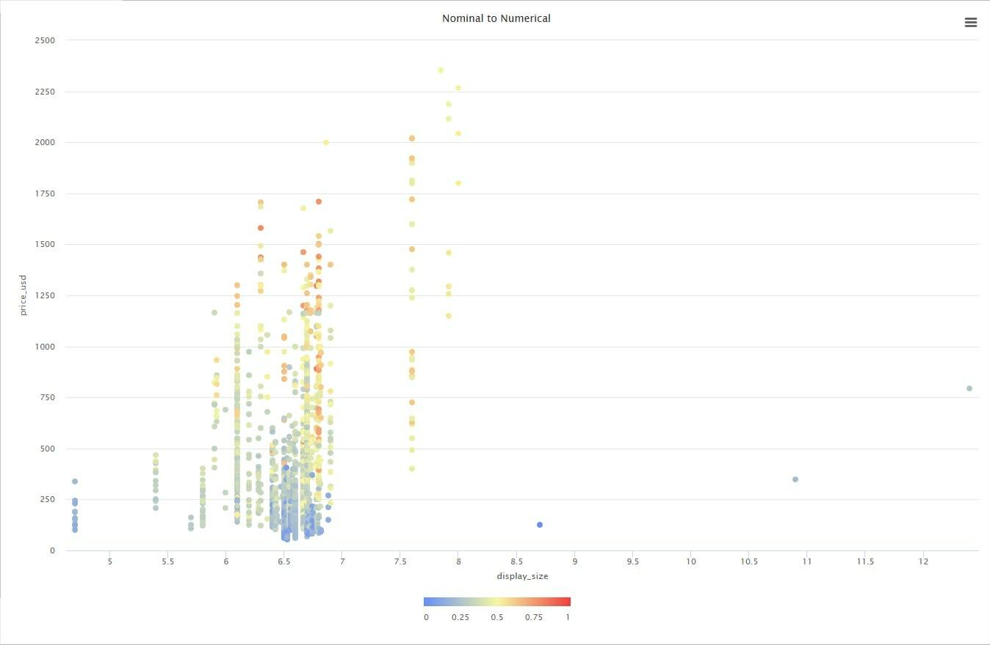

Scatter Plot
- The scatter plot illustrates display_size (x-axis) against price_usd (y-axis) while each datapoint's color denotes price_range_num (low = blue, high = red).
- The distribution of the data straightforwardly shows that the majority of the phones have a display size of about 6.0"-7.0", though in this span, the phones are all price ranges (cheap, mid, expensive) are all intermixed.
- The highest price ranges (orange/red) are typically associated with the top right positioning of the scatter plot, however, they do not necessarily have a larger display than their cheaper counterparts.
- Thus, display size is not a sufficient indicator of the price of a phone. There are multiple phones on the market with a similar range of display sizes that are priced very differently.
- This is relevant to the problem at hand. The problem is determining whether a phone's price is too high or reasonable to flow to its specifications. This scatter plot illustrates the need to consider and analyze multiple specs (RAM, storage, battery, etc. with models like a Decision Tree or k-Means) to find a phone's display size is not sufficient to determine if a phone is actually substantial enough to justify it.

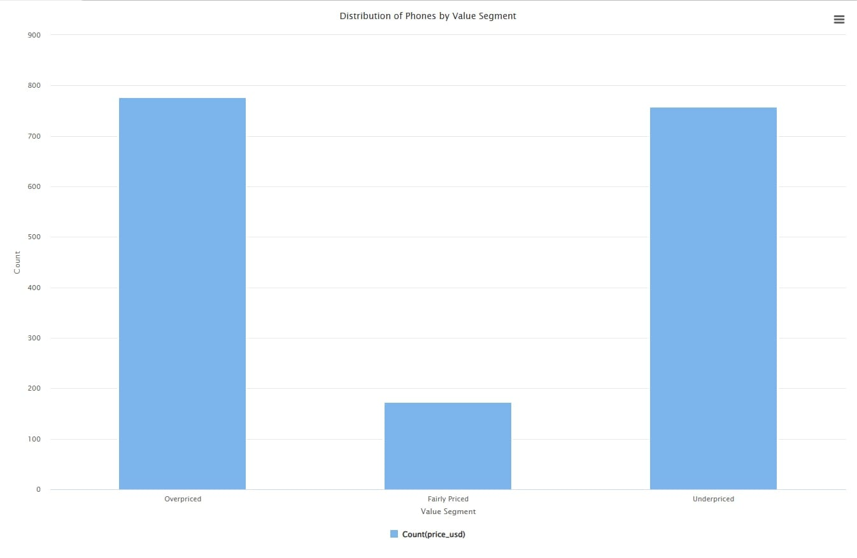
Bar Graph
The bar chart illustrates the different value segments and the corresponding quantity of cellular devices in each segment.
- Overpriced: 777 phones
- Underpriced: 758 phones
- Fairly Priced: 173 phones
- The majority of phones in the dataset are assessed as either Overpriced or Underpriced, with a small few classified as Fairly Priced letting the specs vs median price.
- Our smartphone price vs specs analysis tool aims to assist users make informed purchasing decisions.
- The chart data suggests that a smartphone’s price is not a reliable indicator of value or a fair price.
- This further justifies the purpose of our models (Decision Tree, k-Means, Association Rules) to analyze specifications and pricing in unison to identify and emphasize the smartphones which provide a worse or better value proposition.

Data Preparation
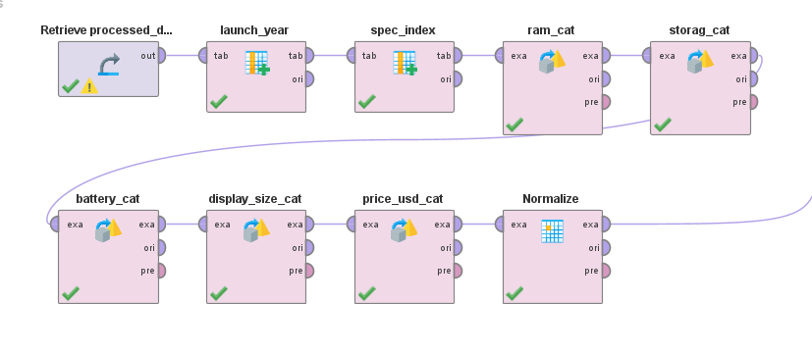
Attribute reduction
- The original dataset has 38 columns, but not all will be useful in modeling.
- When modeling, we centered in price + technical specs: price_usd, price_range, ram, storage, battery, display_size, ppi_density, weight, os_type, chip_company, foldable, fingerprint, nfc, usb, and the engineered spec_index.
- We largely omitted descriptive / text-heavy attributes, such as phone_model, store, dimensions, colors, features_sensors, video, full cpu/gpu strings, etc. Functionally, this is our attribute reduction: they stay in the CSV, but they are excluded from the modeling datasets.

Normalization
- We normalized numeric features that will be used for k-Means clustering, as k-Means is distance-based and is extremely sensitive to the scale of the variables.
- We used min max normalization to rescale ram, storage, battery, display_size, ppi_density, weight, and spec_index.
- Tree-based models (Decision Tree) and Association Rules don’t strictly require normalization. So normalization is mainly being done for the clustering model.

Types of Data: Binning, Aggregation, Discretization
New Numeric Feature
- For spec_index, We calculate overall specification score by normalizing ram, storage, battery, and ppiFor: _density and aggregating them. This yields a single number that indicates the hardware strength of a phone.

Discretization and Binning for Association Rules
- For ram_cat: Low RAM (≤4GB), Mid RAM (5–8GB), High RAM (>8GB).
- For storage _cat: Low Storage (≤128GB), Mid Storage (129–256GB), High Storage (>256GB).
- For battery_cat: Small Battery (≤4000mAh), Mid Battery (4001–5000mAh), Big Battery (>5000mAh).
- For display_size_cat: Small (≤6.0"), Medium (6.1–6.7"), Large (>6.7").
- For price_usd_cat: Budget (≤$300), Mid ($301–$600), High (>$600).

For the following labels We assigned the binary for the sake of simplifying rule constraints:
- For foldable (0/1): "Non-Foldable" / "Foldable".
- For nfc (0/1): "No NFC" / "Has NFC".
These categorical features have been purposely designed for Association Rule mining since purely categorical items function more efficiently than continuous numerical values.

Missing values
- We checked for missing values in every column in processed_data2.csv.
- The majority of key numerical and categoricals that are in the analysis and models (such as price, RAM, storage, battery, display size, ppi, weight, price quantile, price_range, os_type, etc.) are missing 0 values out of the total of 1,708 rows.
- The only column with missing values for gpu_company (71 missing) and cpu_core (18 missing). We didn't perform any imputation as we didn't consider these columns important features in the models.

Outliers
- We checked some summary statistics and noted that from price_usd, for instance, has a min value of about $52.63 and a max value of about $2,353.82, with a majority of the phones ranging in value from around $170 to $550. The high price point values are true outliers as they correspond to genuine flagship devices and are not errors.
- Unique values are important for demonstrating a full range of consumer products (the opposite of capping outliers). Thus, We didn't remove or cap outliers.
- In fact, we rely on the outliers for:
  - (1) normalization for k-Means, so that very expensive phones do not dominate distances too much and
  - (2) decision trees and association rules. The latter is important as it can handle skewed price distributions and does not highly strict removal of outliers.

Model Preparation
The 3 modeling techniques we chose are supervised classification (Decision tree), unsupervised clustering model (k-Means), and lastly unsupervised rule based model (Association Rule).

Decision Tree
This will be used to predict which price range a phone belongs to based on its specs. It's like giving them an if-then rule, this will help explain which specs push a phone into a higher price segment.

k-Means
This will group phones into clusters that have similar specs and price. It will help us with understanding the natural segmentation of the smartphone market.

Association Rule
This is for finding the if-then patterns in the data, like what if ram is high and storage is also high, this would mean the price would also be high. This would show us which combination of specs would usually appear together and how they relate to the price_range. It supports our problem, which is what kind of spec bundles tend to be cheap, mid-range, or expensive.

Rapidminer Process Flow
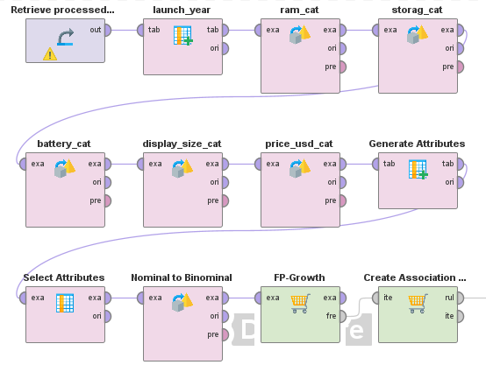
Association Rule
- Retrieve data
- Load the dataset processed_data2 from the RapidMiner repository.
- Discretize numeric specs
- Convert continuous numeric attributes into categories (e.g. Low / Medium / High):
  - ram → RAM bins
  - storage → storage bins
  - battery → battery bins
  - display_size → screen size bin
  - price_usd → price level bins
- Generate additional labels
- Create easier-to-read categorical labels:
  - foldable_label (Foldable vs Non-Foldable)
  - nfc_label (Has NFC vs No NFC)
- Select relevant attributes
  - Keep only the variables used for rule mining, such as:
ram, storage, battery, display_size, price_usd, chip_company, gpu_company, os_type, phone_brand, foldable_label, nfc_label, price_range.
- Convert to binominal (dummy-coded)
  - Apply Nominal to Binominal so that each category becomes its own binary item (e.g. “RAM_High”, “Storage_Low”, “PriceRange_High”).
- Find frequent itemsets (FP-Growth)
- Run FP-Growth to find combinations of items that appear together often in the data
- Minimum support ≈ 0.05 (items must appear in at least ~5% of phones).
- Generate association rules
  - Use Create Association Rules on the frequent itemsets to produce rules like:
  - “IF RAM_High AND Storage_High THEN PriceRange_High”
  - Apply thresholds such as:
    - Minimum confidence ≈ 0.70
    - Minimum criterion value (e.g., lift) ≈ 0.80

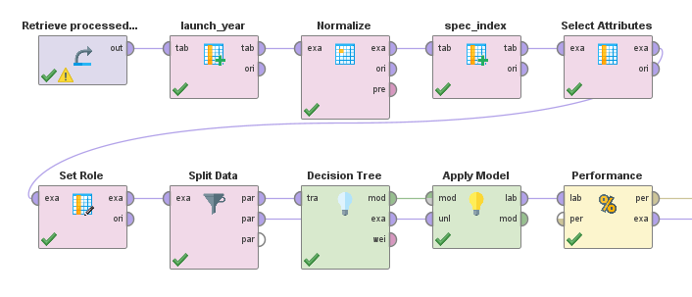
Decision Tree
- Retrieve data
- Generate launch year
- Use Generate Attributes to create
launch_year = date_get(launch_date, DATE_UNIT_YEAR)
so the model can use just the year instead of the full date.
- Normalize key numeric specs
- Apply Normalize (min–max) to:
battery, ppi_density, ram, storage
(mainly to support the later spec_index calculation; trees don’t strictly need it but it’s okay).
- Generate spec_index (overall spec score)
- Use Generate Attributes to create:
spec_index = (ram + storage + battery + ppi_density) / 4
using the normalized values, to summarize overall hardware strength.
- Select modeling attributes
- Use Select Attributes to keep only the columns used by the model:
battery, battery_size, chip_company, colors_available, display_size, fingerprint, foldable, gpu_company, launch_year, nfc, os_type, phone_brand, ppi_density, ram, spec_index, storage, usb, weight, price_range.
- Set target (label) column
- Use Set Role to set price_range as the label (classification target) and keep all other selected attributes as regular predictors.
- Split data into training and testing sets
- Use Split Data to divide the dataset into:
    - 70% training data
    - 30% testing data (with shuffling enabled).
- Train the Decision Tree model
- Apply the Decision Tree operator on the training partition using the selected attributes to learn rules that predict price_range.
- Apply the model to test data
- Use the Apply Model to generate predicted price_range for the test partition.
- Evaluate model performance
- Use Performance (Classification) to compute metrics such as accuracy and a confusion matrix, comparing predicted vs actual price_range.

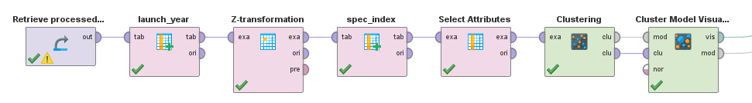
Cluster Model
- Retrieve data
- Generate launch year
- Use Generate Columns to create:
  - launch_year = date_get(launch_date, DATE_UNIT_YEAR)
- Normalize numeric attributes (Z-transformation)
- Apply Z-transformation to standardize the included attributes (mean 0, convert attributes std ):
  - battery, display_size, launch_year, ppi_density, price_usd, ram, spec_index, storage, weight
- Generate spec_index
- Use Generate Columns again to compute an overall spec score:
    - spec_index = (ram + storage + battery + ppi_density) / 4
    - (This uses the standardized values of those specs.)

- Select clustering attributes
- Keep only the numeric features used by k-Means:
battery, display_size, launch_year, ppi_density,
price_usd, ram, spec_index, storage, weight

- Run k-Means clustering
- Operator: Clustering (k-Means) with key settings:
  - k = 4 clusters
  - Distance measure: Euclidean on the standardized numeric features
  - add_cluster_attribute = true (adds a new attribute like cluster for each phone)

- Cluster Model Visualizer
- Visualize the resulting clusters to inspect how phones are grouped.

Experiments And Results

Association Rule
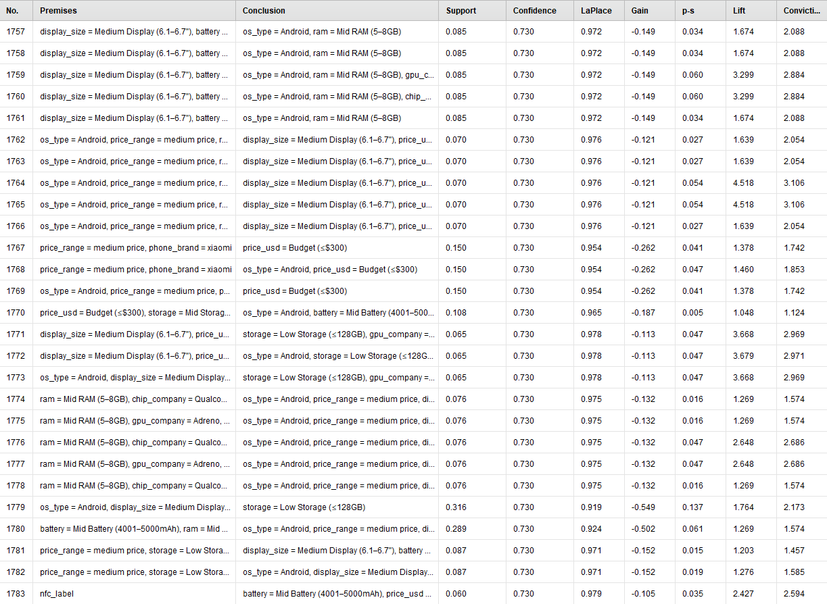

The association rules show which spec bundles are popular in each price range. For instance, Android phones that have displays that are medium in size, and mid-sized batteries, 73% of the time have 5–8GB RAM (support ≈ 8.5%, lift ≈ 1.67). It can be seen that budget Android phones tend to have mid-sized batteries and are most likely to be 128–256GB storage. Hence, we conclude that the ‘typical’ budget or mid-range phones in this dataset are Android devices that have mid RAM, mid battery, and medium display size, and have features like NFC which are common even in cheap phones.

Decision Tree
Performance Matrix

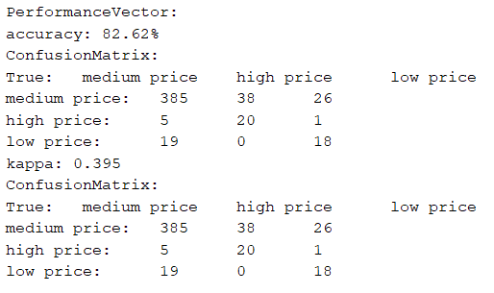

The confusion matrix and class-wise precision and class-wise recall show the model does best at classifying medium-price phones (recall 94.13%, precision 85.75%) and does worse for the class of prices that are high and low (recall 34.48% and 40.00% for high and low respectively).
The cells pointed out by the squares show that a lot of high- and low-price phones that are true are incorrectly classified as medium-price, which suggests that the mid-range phones have clearer and more consistent specifications than the low and high ends.

Performance Accuracy

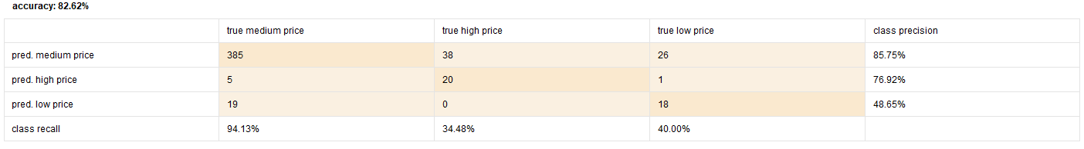

This result shows that the confusion matrix and the other metrics of prediction still have the same value of accuracy of 82.62% and value of kappa of 0.395 which is a sign of moderate agreement of the prediction and the true values.
The result is consistent that the greatest number of mistakes is the same as before, i.e. high and low price phones are wrongly classified as medium which is the same outcome as the predicted performance matrix and which shows that the decision tree easily separates medium and non medium-price phones, which means that it is clear that it is low and high price is not easy

Example Set Table
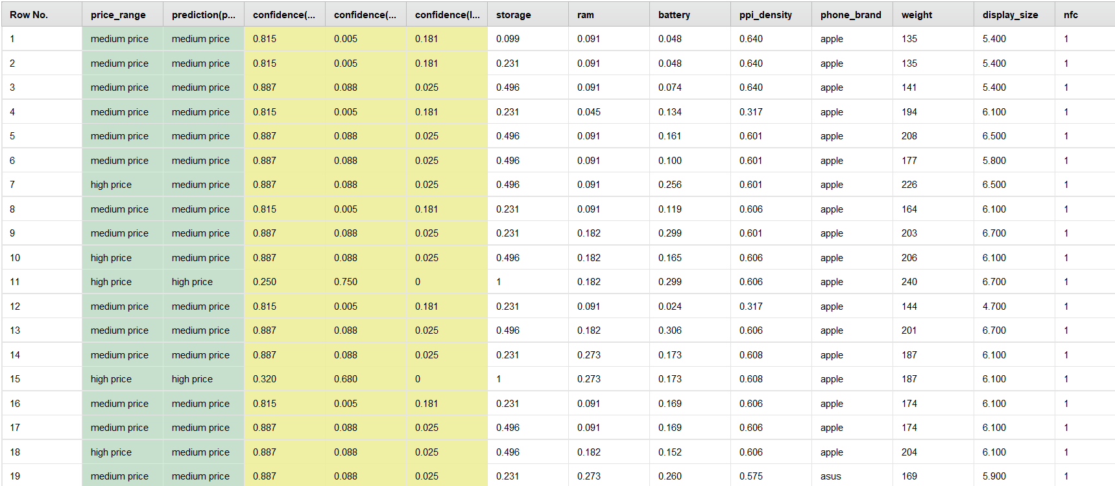

This table shows individual phones with their true price_range, the model’s prediction(price_range), and the confidence for each class (e.g., confidence for medium, high, and low).
Rows where price_range = medium and prediction = medium usually have high confidence for medium and very low confidence for the other classes, matching the strong medium-class recall seen in Images 1 and 2.
Rows where a true high or low phone is predicted as medium illustrate the earlier point: the model often pulls high/low phones into the medium class, meaning their specs look closer to typical mid-range patterns than to clearly low or clearly high.

Cluster Model
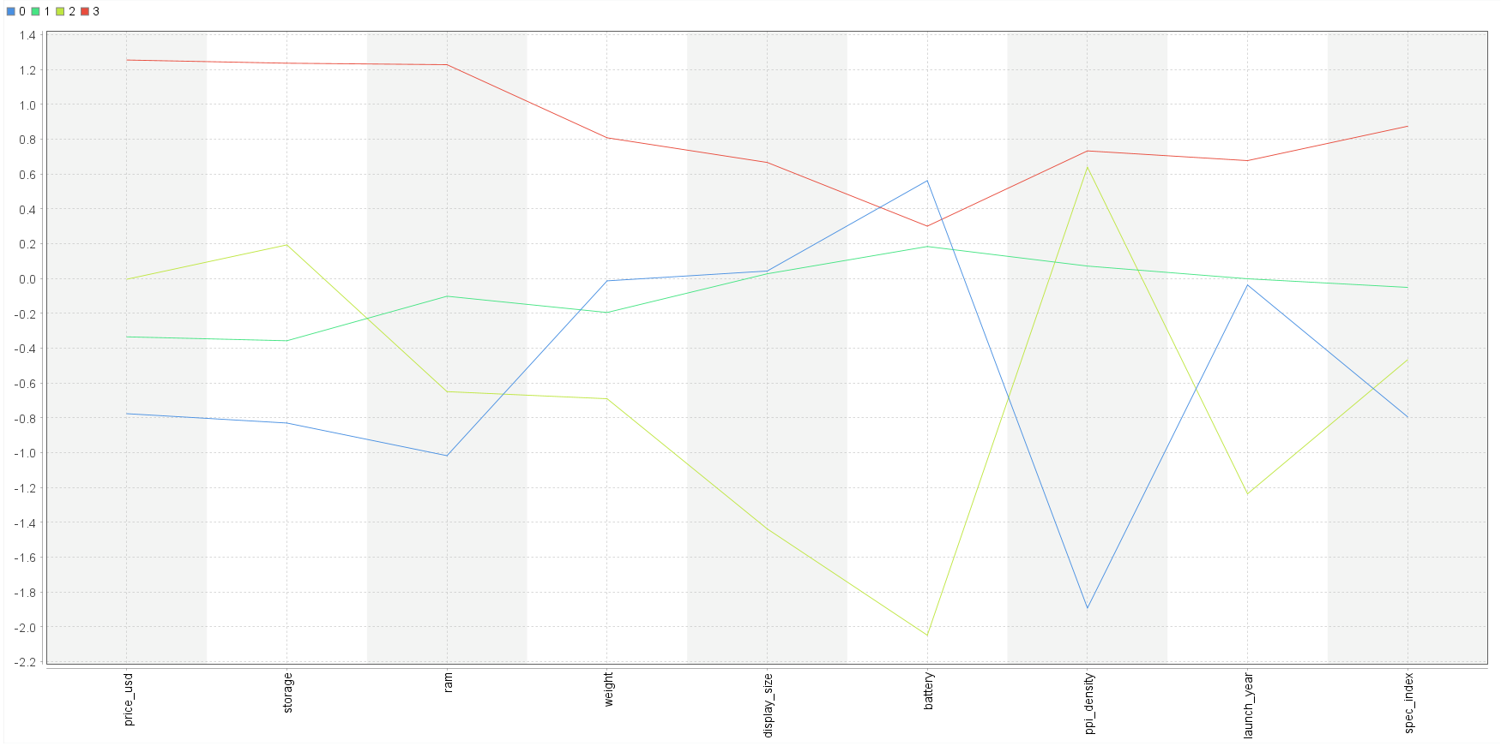
Line Graph
This line plot shows the cluster centroids (average standardized values) for each of the four k-Means clusters across the main attributes: price_usd, storage, ram, weight, display_size, battery, ppi_density, launch_year, and spec_index. Each coloured line (0–3) represents one cluster. Cluster 3 (red) stays well above zero on almost every attribute, especially price, storage, RAM, ppi_density, launch_year, and spec_index, confirming it as the flagship/high-end group with newer and stronger specs. Cluster 0 (blue) is mostly below zero on price, storage, RAM, ppi_density, and spec_index, marking it as a low-price, low-spec cluster, though its battery is slightly above average. Cluster 1 (light green) stays just a bit below zero on most attributes, forming a large “slightly below average” mid/low segment. Cluster 2 (yellow-green) dips very low on battery, display_size, RAM, and launch_year, showing older, small-screen phones with small batteries and weaker specs. Overall, the plot makes it easy to see how each cluster’s spec profile differs and supports the interpretation of budget, lower-mid, older/legacy, and flagship segments in the smartphone market.
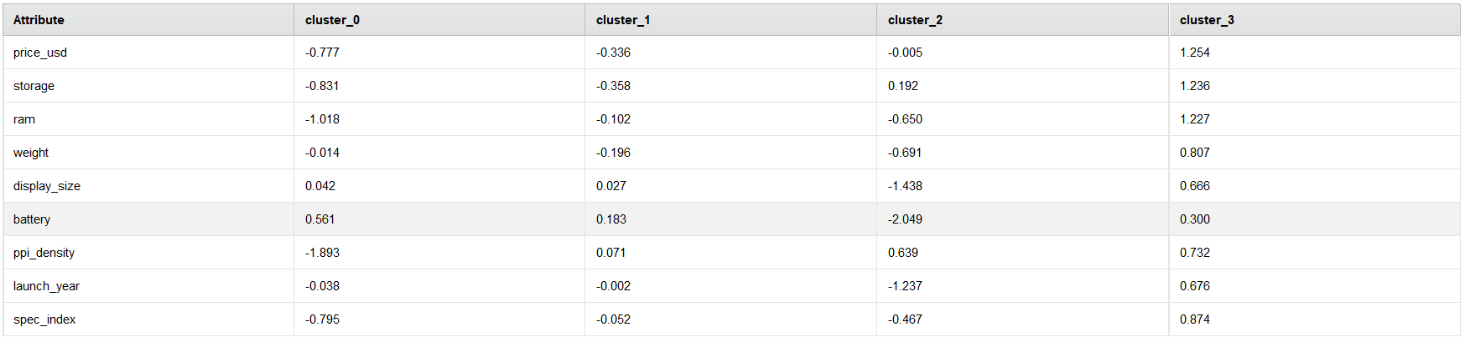

Cluster Centroid
This table shows the actual cluster centroids as standardized values (z-scores), where negative numbers mean below the dataset average and positive numbers mean above. For Cluster 0, attributes like price_usd, storage, ram, ppi_density and spec_index are all strongly negative, which numerically confirms that this group is low price and low spec. Cluster 1 has values close to zero with mild negatives, indicating specs and price that are only slightly below average. Cluster 2 has very negative scores for battery, display_size and launch_year, revealing older phones with smaller screens and batteries. Cluster 3 has strong positive values for price_usd, storage, ram, ppi_density, launch_year and spec_index, showing that this cluster contains newer devices with higher specs and higher prices. Together, these centroids support the interpretation of the clusters as budget, lower-mid, older/legacy, and flagship segments.

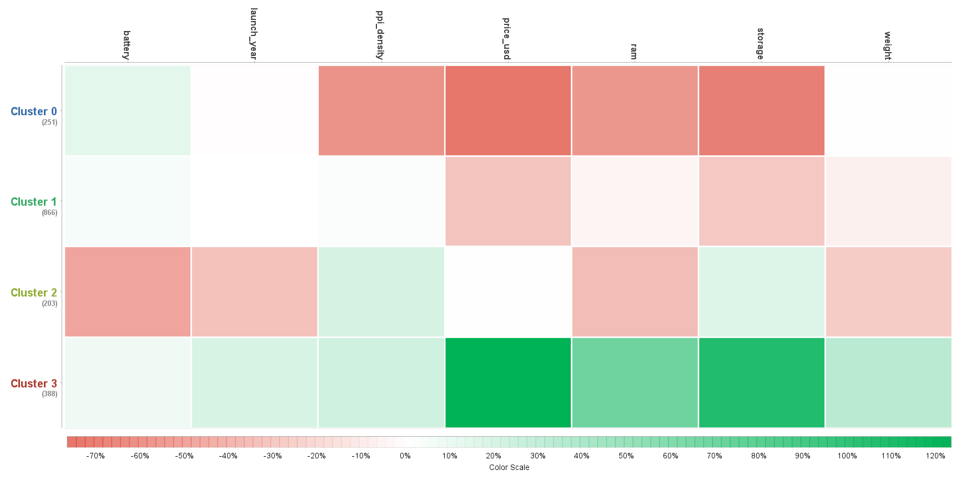
Heatmap
This heatmap compares the four k-Means clusters (rows) against the main numeric attributes (columns) using colors to show how far each cluster is from the overall average. Green cells mean values are higher than the dataset average, while red/pink cells mean they are lower. Cluster 0 shows strong red on price_usd, storage, ppi_density and ram, indicating very cheap phones with low storage, weaker screens, and low RAM. Cluster 1 is only slightly below average on price and storage, so it looks like a large group of “typical” affordable phones with slightly reduced specs. Cluster 2 is much lower than average on battery, ram, and launch_year, which identifies older, small-battery, low-RAM phones. Cluster 3 is bright green on price_usd, storage, ram and related specs, clearly highlighting the flagship segment with high specs and high prices.

